Greco Feudal GDD

# Overview

## Summary

2 players share a screen and run towards each other. They navigate a 2D symmetrical map, facing enemies and obstacles along the way until they meet in the middle and have a climactic battle to decide a war.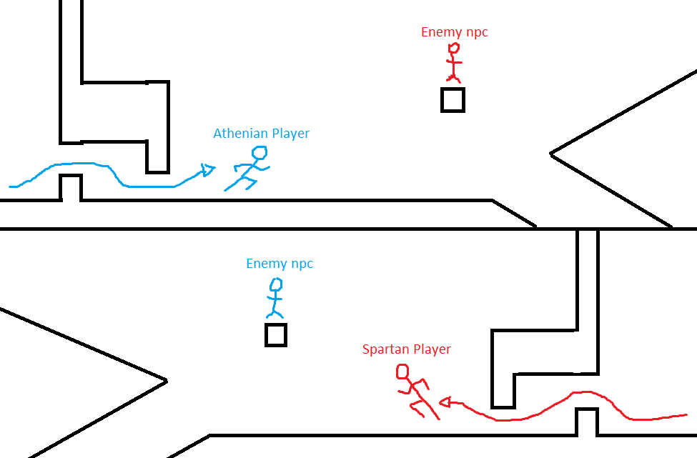

## Pillars

1. Unique Culture Blend
2. Player vs Player
3. Rapid Gameplay

## Story

Athens broke the treaty between them and Sparta, and thus the Peloponnesian war started. Due to their differing strengths the war has been at a stalemate for quite some time, so something must change. The leaders of each nation, Pericles and Archidamos have agreed to send in their greatest warriors (the players) to duel for the fate of the war.

## Moral Argument

Political negotiations and all-out war cause misery, suffering, and are never ending. The only good way to solve a dispute is one on one combat between individuals that embody the nations.

This will be shown through:

1. Negotiations and war failing to achieve peace (cutscene)
2. A one-on-one battle commences (gameplay)
3. The bloodshed ends and peace falls over the land (cutscene when someone wins)

Each side has their reasons to fight:

* Athens
  + Sparta initiated combat first and we are just defending ourselves.
  + Sparta is the reason diplomacy failed and continued the bloodshed.
* Sparta
  + Athens broke the Thirty-Year Treaty and thus forced our hand to war.
  + Athens has been using underhanded tactics to gain the advantage dishonourably.

## Aesthetic

Ancient times with a mix of Japanese and Greek culture. Inspiration from anime with the over-the-top action scenes and fast-paced editing. It’s mainly Greek for the story and Japanese because the anime tropes and style such as unrealistic physics and overly exaggerated actions/dialogue. This style also hasn’t been completely explored and has the potential to work very well with each other.

## Unique Selling Point

* A blend of cultures that hasn’t been explored before. A mix of Greek and Japanese culture that creates a new and interesting aesthetic.
* 2 players facing off in a rapid approach and duel that tests skills like coordination, judgement, and reaction time.
* Symmetrical gameplay on a single screen and keyboard.

## Target Market

This game is targeted towards people like:

* Jamie Steven: Adult, father, served in military, likes rock music
* Ken Ward: Adult, married, likes pop culture, likes in-game rankings, likes top tier skilful gameplay, likes continued support for online games
* Sam Edwards: Adult, likes competitive experiences, likes 2-4 player multiplayer, makes games
* Nathan Schaaf: Likes competitive experiences, likes small versus gameplay, likes platformers
* Martin Dogen: Likes Competitive and cooperative games, plays majority multiplayer games, likes continued support for online games

Things some of these people have in common are:

* Playing games such as SpeedRunners and Nidhogg
* Likes continued support for multiplayer games such as rankings and new content
* Lack time to play long experiences and prefer quick games
* Likes competition and skill based gameplay
* Likes some aspects of unbalanced gameplay such as SpeedRunners

Platform:

* Windows PC

Age Rating:

* ESRB Teen 13+

# Art Direction

## Platform Design

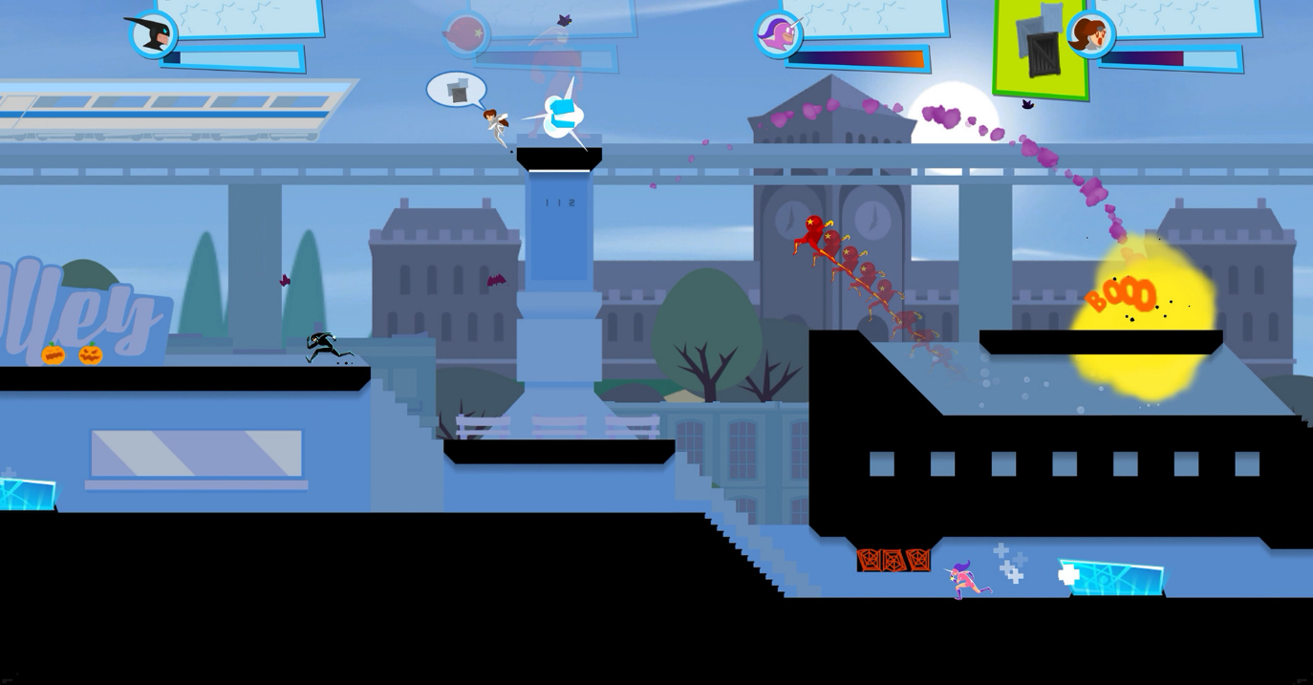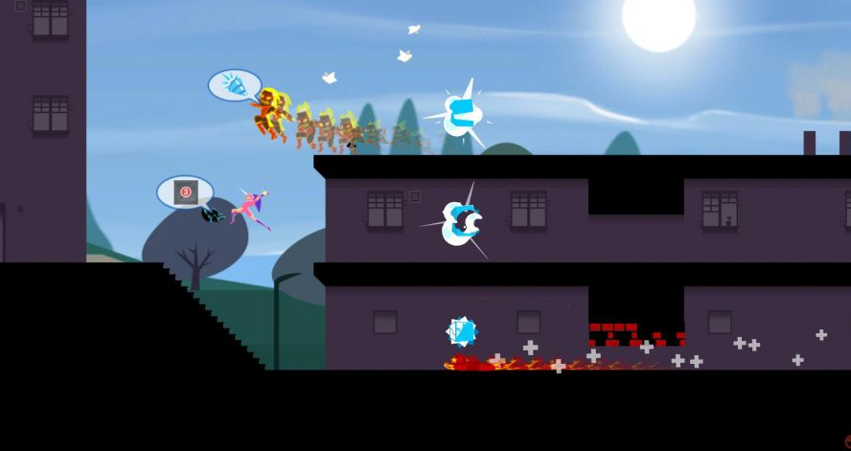

Different paths that the player can choose.

Floating platforms that are supported by background elements.

## Art Style



Background plates that add depth. Less detailed than foreground

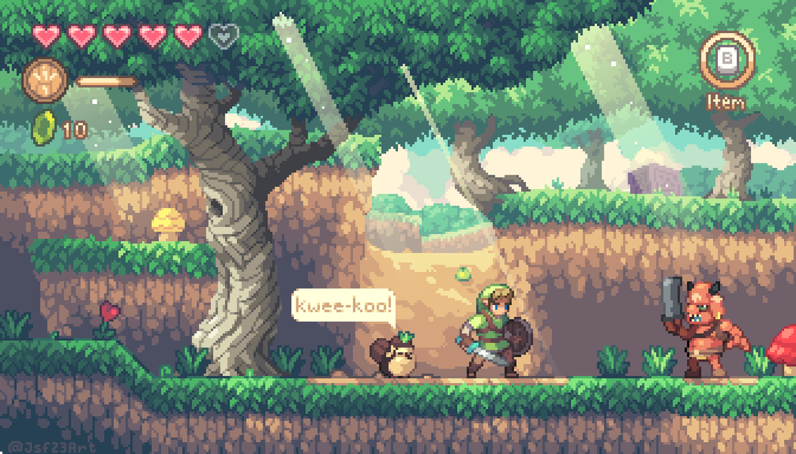

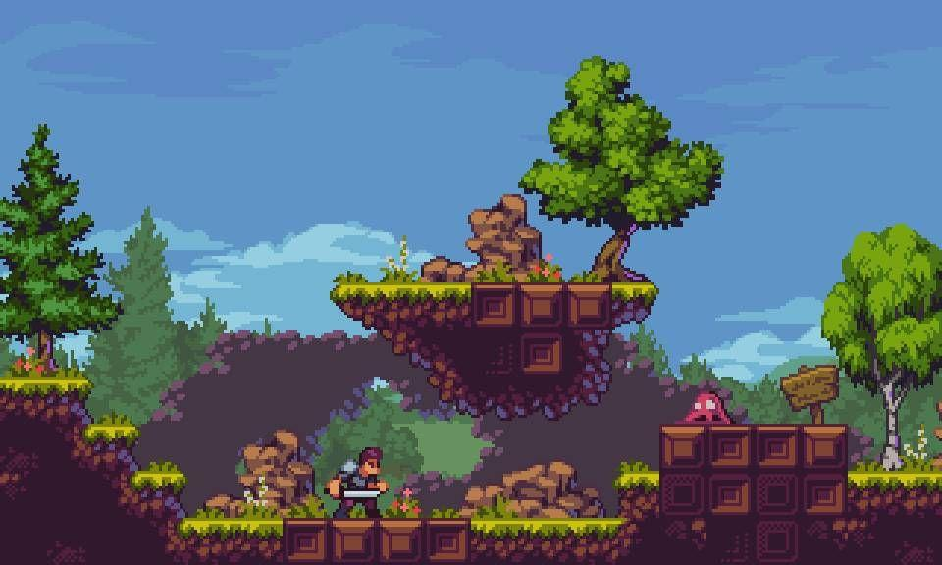

Pixelated general shape and low detail.

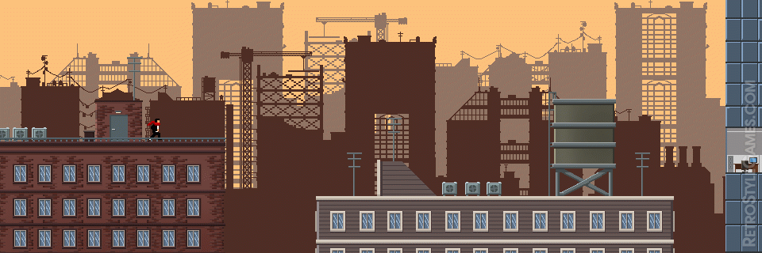

Not too detailed environment. Just enough to tell what it is.

## Content

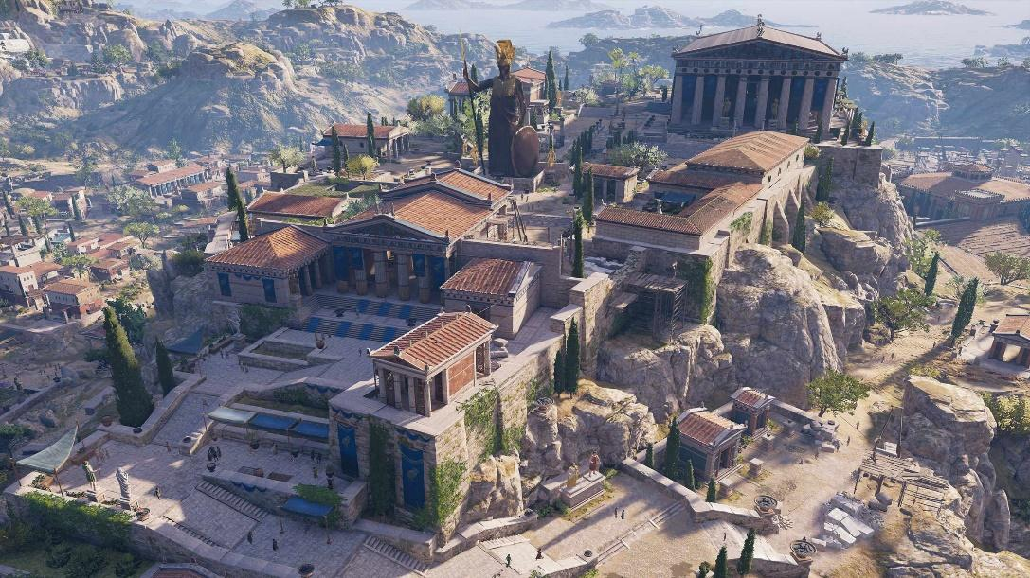

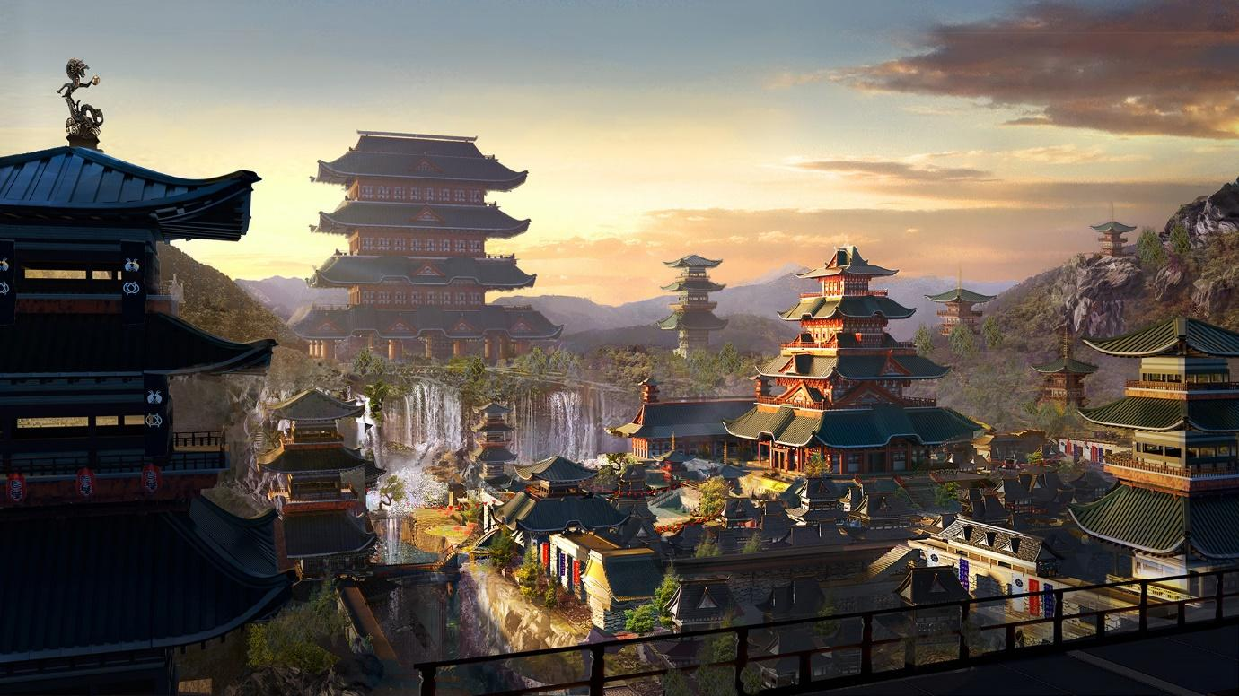

Combination of Greek and Japanese architecture

# Gameplay

## Description

Each player uses half of one screen (top and bottom) and automatically runs towards the other.

The map is branching and allows for different pathways that all eventually lead to the middle where the final battle will happen.

Along the way of these paths there will be obstacles such as walls to slide under and crates to jump over.

There are also enemies in the path that can be killed for special items that increase your abilities for the final battle.

When the players meet, they must face off in a quick time event competition that simulates the quick strikes they are giving, until one of them loses all their health.

## Loops

# Mechanics

All mechanics are for the player as NPCs are unmoving hazards.

## Run

Player automatically runs forward at an unchanging speed which is uninterruptible. (If they hit a wall or enemy they just lose health instead of coming to a stop.)

## Jump

Player can jump to avoid obstacles/enemies and change their path. Any flat vertical surfaces will be broken through (like a wood wall) and they won’t be able to get stuck on corners.

## Slide

Player can slide underneath obstacles like small gaps. Has a cooldown and cannot be performed mid-air.

## Slice & Dagger Throw

When the player is on the ground and attacks they slash forward. This kills enemies in one hit.

When the player is in the air and attacks they throw a dagger at the nearest enemy. It aims directly at them with no player input required and takes them out in one hit.

## Duel Showdown

Quick time event requiring the players to face off with accurate button presses.

# Hazards

## Enemies

All enemies are stationary and die in one hit.

**Normal Units:**

* Injure player slightly when run into

**Special Units:**

* Glow to indicate difference
* Drop special items
* Injure player moderately when run into

## Obstacles

**Jump Hazards**

* Objects like fences and crates that damage the player when run into

**Slide Hazards**

* Objects like low walls and fences that damage the player when run into

# Controls

## Player 1

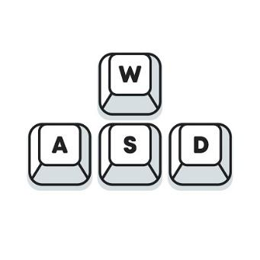Jump – W

Slide – S

Slice & Dagger – D

## Player 2

Jump – Up Arrow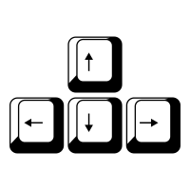

Slide – Down Arrow

Slice & Dagger – Left Arrow